

TRIBHUVAN UNIVERSITY

INSTITUTE OF ENGINEERING

PULCHOWK CAMPUS

**COVERT: SECRET MESSAGING THROUGH IMAGE STEGANOGRAPHY AND FACE RECOGNITION**

By:

**Ram Maharjan (071/BCT/530)**

**Sanjay Gharti (071/BCT/534)**

**Shailesh Kandel (071/BCT/537)**

**Shova Thapa (071/BCT/540)**

A PROJECT WAS SUBMITTED TO THE DEPARTMENT OF ELECTRONICS AND COMPUTER ENGINEERING IN PARTIAL FULLFILLMENT OF THE REQUIREMENT FOR THE BACHELOR’S DEGREE IN ELECTRONICS & COMMUNICATION / COMPUTER ENGINEERING

DEPARTMENT OF ELECTRONICS AND COMPUTER ENGINEERING

LALITPUR, NEPAL

August 5, 2018

TRIBHUVAN UNIVERSITY

INSTITUTE OF ENGINEERING

PULCHOWK CAMPUS

DEPARTMENT OF ELECTRONICS AND COMPUTER ENGINEERING

The undersigned certify that they have read, and recommended to the Institute of Engineering for acceptance, a project report entitled "Covert: Secret Messaging through Image Steganography and Face Recognition" submitted by Ram Maharjan (071/BCT/530), Sanjay Gharti (071/BCT/534), Shailesh Kandel (071/BCT/537) and Shova Thapa (071/BCT/540) in partial fulfilment of the requirements for the Bachelor’s degree in Electronics & Communication / Computer Engineering.

___________________________________________________

Supervisor: Prof. Dr. Subarna Shakya

Department of Electronics and Computer Engineering

Institute of Engineering, Pulchowk Campus

___________________________________________________

Internal Examiner: Dr. Dibakar Raj Pant

Head of Department, DOECE

Institute of Engineering, Pulchowk Campus

___________________________________________________

External Examiner: Mr. Suresh Kumar Regmi

Managing Director

Professional Computer System Pvt. Ltd.

**DATE OF APPROVAL:**

# COPYRIGHT

The authors have agreed that the Library, Department of Electronics and Computer Engineering, Institute of Engineering, Pulchowk Campus may make this report freely available for inspection. Moreover, the authors have agreed that permission for extensive copying of this project report for scholarly purpose may be granted by the supervisors who supervised the project work recorded herein or in their absence, by the Head of the Department wherein the project report was done. It is understood that the recognition will be given to the authors of this project and to the Department of Electronics and Computer Engineering, Pulchowk Campus, Institute of Engineering in any use of the material of this report. Copying or publication or the other use of this report for ﬁnancial gain without approval of the Department of Electronics and Computer Engineering, Institute of Engineering, Pulchowk Campus and authors’ written permission is strictly prohibited.

Request for permission to copy or to make any other use of the material in this report in whole or in part should be addressed to:

Head

Department of Electronic and Computer Engineering,

Institute of Engineering, Pulchowk Campus,

Lalitpur, Nepal

# ACKNOWLEDGEMENT

We would like to express our sincere and deepest gratitude to Department of Electronics and Computer Engineering for providing us the platform for carrying out our major project.

We are heartily thankful to our supervisor Professor Dr. Subarna Shakya Sir, who has the attitude and the substance of a genius. Without his expertise and guidance in this subject matter, this report wouldn’t have seen light of the day. He continually and convincingly conveyed a spirit of adventure in regard to research and motivation.

We are thankful to and fortunate enough to get constant encouragement, support and guidance from all friends and teachers who helped us for doing this project. Finally, we would like to extend our heartfelt thanks to our beloved parents whose blessings and encouragement were always there as a source of strength and inspiration.

Any kind of suggestion or criticism will be highly appreciated and acknowledged.

# ABSTRACT

The project entitled as “Covert: Secret Messaging through Image Steganography and Face Recognition” consist of the features like Cryptography, Steganography and Face Recognition which help to make a secure communication between the user. With the advancement in the technology, there is also threats in the privacy of the user being leaked. The product features two layers of security; first the message send by the user is encrypted securely using RSA algorithm with the key of 2048 bits, and then cipher text is encoded into the Image. Image steganography ensures that it doesn’t create suspicion in the intruder’s mind and even if encoded image creates the suspicion, intruders won’t be able to extract the plaintext from it because it is being encrypted using RSA encryption. Local Binary Pattern Histogram (LBPH) algorithm for face recognition is also working satisfactory. Along with the security, this project has the feature of adding friends, checking the availability of the user, editing profile and so on. This combination takes security to the new level and with this, the project was able to meet its objectives.

*Keywords: Steganography, Cryptography, Face Recognition, Face Detection*

# TABLE OF CONTENTS

PAGE OF APPROVAL II

COPYRIGHT iii

ACKNOWLEDGEMENT v

ABSTRACT vi

TABLE OF CONTENTS vii

LIST OF FIGURES ix

1. INTRODUCTION 1

1.1. Background 1

1.2. Problem Statement 2

1.3. Related Theory 2

1.3.1. Image Steganography 2

1.3.2. Face Detection using Voila-Jones algorithm 5

1.3.3. Local Binary Pattern Histogram (LBPH) Algorithm 11

1.3.4. Cryptography 13

1.3.5. Network Programming 18

1.4. Objectives 19

2. LITERATURE REVIEW 20

3.METHODOLOGY 24

3.1. Data Collection and Analysis 24

3.1.1. Primary Data Collection 24

3.1.2. Secondary Data Collection 24

3.2. Image Steganography using LSB method 25

3.3. Face Detection (Voila-Jones algorithm) 26

3.4. Face Recognition (Local Binary Pattern Histogram Algorithm) 27

3.4.1. For Training 27

3.4.2. For Recognition 28

3.5. Cryptography (RSA) 28

4. TOOLS AND TECHONOLOGIES 31

4.1. Python 31

4.2. Django 31

4.3. NumPy 31

4.4. HTML/CSS 32

4.5. JavaScript 32

4.6. PostgreSQL 32

4.7. Git 33

4.8. AJAX (Asynchronous JavaScript and XML) 33

4.9. Django Rest Framework 33

5. Covert Messaging 34

5.1. Features of covert messaging 35

6. SOFTWARE DEVELOPMENT LIFE CYCLE 38

6.1. Agile Software Development 38

6.1.1. Agile Software Development Values 38

6.1.2 Agile Software Development Principles 39

6.1.3. Characteristics of Agile Software Development Process 40

6.1.4. Advantages of Agile Method 42

7. DIAGRAMS 44

7.1. Block Diagrams 44

7.2 UML Diagrams 50

7.2.1 Use-case Diagram 50

7.2.2 Class Diagram 51

7.2.3 Activity Diagram 52

7.2.4 Sequence Diagram 53

8. RESULTS AND ANALYSIS 54

9. CONCLUSION 58

10. REFERENCES 59

APPENDIX A: SCREENSHOTS 62

# LIST OF FIGURES

Figure 1: Five Haar-like patterns. 7

Figure 2: Some supervised examples: (a) positive examples (b) negative examples. 7

Figure 3.Illustration of LBP 12

Figure 4.Block diagram of Encryption 14

Figure 5.Illustration of Symmetric encryption 15

Figure 6.Illustration of Asymmetric encryption 16

Figure 7. Data collection and analysis 25

Figure 8.Block diagram of cryptography 44

Figure 9.Block diagram of steganography 45

Figure 10.Block Diagram of Face detection and training 46

Figure 11.Block Diagram of Face detection in unknown faces 47

Figure 12.Block Diagram of Face Recognition and training 48

Figure 13.Block Diagram for detecting the message 49

Figure 14.Use-case Diagram of system 50

Figure 15.Class Diagram of system 51

Figure 16.Sequence Diagram of system 53

Figure 17.Image After Steganography 55

Figure 18: Change in the retention of neighbor pixel(1) 56

Figure 19: Change in the retention of neighbor pixel(2) 57

Figure 20: Registration Page 62

Figure 21:Login Page 62

Figure 22: Homepage 63

Figure 23: Messaging box 63

Figure 24 : Friendlists 64

Figure 25: Received Friend Requests 64

Figure 26 : Message box after sending Image 65

Figure 27: Viewing Profile 65

# 1. INTRODUCTION

## Background

Nowadays, various modes of communication like LAN, WAN and INTERNET are widely used for communicating information from one place to another around the globe. Such communication networks are open which any one can access easily. They are regularly monitored and an intercepted.

Cryptography is most often associated with scrambling plaintext (ordinary text, sometimes referred to as clear text) into Cipher text (a process called encryption), then back again (known as decryption). It is the process of protecting the contents of a message alone. Plainly visible encrypted messages, no matter how unbreakable will aroused interest and may in themselves be incriminating in countries where encryption is illegal.

Cryptography being having some limitations to establish a secure communication, new means of security i.e. Steganography is used. Steganography is the practice of concealing file, image, message or video within another file, image, message or video so that an eavesdropper (who listens to all communications) cannot even tell that a secret message is being sent. File, image, message or video in which information is hidden is called carrier, the information being hidden is called payload and the resulting image, file or video is called stego. Since Image Steganography is used in this project, our carriers and resulting will be the image and text will be the payload. To make this happen, LSB method of Image Steganography is used.

Face recognition is used as another means of security. Many people get confused with face detection and recognition. Face detection simply detects faces in images or videos or webcam while face recognition detects face and also recognizes whose face it is. Among the different biometric techniques, face recognition may not be most reliable and efficient. However, one key advantage is that it does not require the cooperation of the test subject to work. Properly designed systems installed in airports, multiplexes and other public places can identify individuals among the crowd, without passers-by even being aware of the system. Other biometrics like fingerprints, iris scans, and speech recognition cannot perform this kind of mass identification.

Having all these security systems without having a facility of networking is of no use. So, networking facility is embedded into the system to establish a connection between the user.

## Problem Statement

Internet has become easiest and quickest means of communication in today’s world. Internet has changed the world into global village. With the exorbitant use of the internet to have a communication with others, the threats of data being captured by invaders is also increasing to the massive extent. Capturing of other information and using it for illegal purposes will create chaos in the world. Everyone want their communication to be private so that there will be no leakage of the personal information to the outer world.

## 

## 1.3. Related Theory

### 1.3.1. Image Steganography

Steganography, from the Greek, means covered or secret writing, and is a long-practiced form of hiding information. Steganography is the process of concealing payload with in the carrier due to which it creates the illusion in the invaders mind that there is nothing concealed within it but in reality, there is some stuffs hidden inside it. Image Steganography is the process of concealing payload with in the image (i.e. carrier). Image Steganography is one step ahead than the cryptography as it doesn’t drag the attention of the eavesdropper to it as an object of scrutiny that there is something but this is not the case in cryptography. Eavesdropper knows that message is hidden inside it by looking the cipher text and what he need is decryption key which help to convert the cipher text to plain text. Considering a limitation of the cryptography, one of the steganography techniques called Image Steganography using LSB (Least Significant Bit) method is implanted in this project. It is known that the pixels in an image are stored in the form of bits. Images are categorized into various formats, each having their own characteristics, advantages and disadvantages. Some of the popular formats used today are PNG, JPEG, BMP, GIF etc. In this project, PNG image is used as it provides lossless compression so that there is no chance of message that had been stored get scrambled.

#### 1.3.1.1. An overview of LSB

A digital image is a 2- Dimensional array of varying intensity levels. For gray-scale image, 8 bits per pixel are used whereas in a color image following RGB model, there are 24 bits/pixel, 8 bits assigned to each color components. Least significant bit (LSB) insertion is a common, simple approach to embedding information in a cover image. The LSB uses a simple concept of replacing the last bit with the message bit. An 800 × 600 pixel image, can thus store a total amount of 1,440,000 bits or 180,000 bytes of embedded data

For example a grid for 3 pixels of a 24-bit image can be as follows: (00101101 00011100 11011100) (10100110 11000100 00001100) (11010010 10101101 01100011) When the number 200, which binary representation is 11001000, is embedded into the least significant bits of this part of the image, the resulting grid is as follows: (00101101 00011101 11011100) (10100110 11000101 00001100) (11010010 10101100 01100011) Although the number was embedded into the first 8 bytes of the grid, only the 3 underlined bits needed to be changed according to the embedded message. On average, only half of the bits in an image will need to be modified to hide a secret message using the maximum cover size. Since there are 256 possible intensities of each primary color, changing the LSB of a pixel results in small changes in the intensity of the colors. These changes cannot be perceived by the human eye - thus the message is successfully hidden. With a well-chosen image, one can even hide the message in the least as well as second to least significant bit and still not see the difference. The advantage of LSB embedding is its ease and many techniques use these methods.

**Advantages of LSB**

1. LSB algorithm is quick and easy to implement.

2. Causes minimal distortion per unit area of image.

3. LSB insertion also works well with gray-scale images

**Disadvantages of LSB**

1. Low robustness.

2. Highly vulnerable to cropping, contrasting and another sort of image processing.

**Image Steganography using LSB method Algorithm**

1. Select cover-object CO as an input.

2. Encode the CO in binary.

3. The Secret Message, m.

4. Encode the m in binary.

5. Choose one pixel of the CO.

6. Use a pixel selection to hide information in the CO.

7. Save the new image (Stego-object) SO in the desired format.

### 1.3.2. Face Detection using Voila-Jones algorithm

Face Detection is the process of detecting face in the image which is the first step before face recognition. For Face Detection, Voila-Jones Face Detection algorithm is used which is developed by P.Voila and M.J. Jones, first ever real-time face detection system. There are three ingredients working in concert to enable a fast and accurate detection: the integral image for feature computation, Adaboost for feature selection and an attentional cascade for efficient computational resource allocation. The reason behind using this algorithm are Robustness- very high detection rate (true-positive rate) & very low false- positive rate always; Real time - For practical applications at least 2 frames per second must be processed.; Face detection only (not recognition) - The goal is to distinguish faces from non-faces (detection is the first step in the recognition process); It consists of four steps i.e. Haar-feature selection, Creating an integral image, Ada-boost training and Cascading classifiers. Haar-feature selection is the process of extracting digital features from the image. Haar-feature selection is a weak classifier as it takes all the features from the image which may be redundant for us and by using Ada-boost training which will eliminate the irrelevant features extracted during haar-feature selection and consider only the relevant features required to detect a face which helps to make a strong classifier. And then classifier cascading is done where classifier is combined in a cascade which allows the background regions of the image to be quickly discarded.

Haar-cascade (Wilson & Fernandez, 2006) is a method, invented by Viola and Jones (Viola & Jones, 2001), which trains a machine learning for detecting objects in a picture. In this context, it can be used to detect faces. The name of this method is composed of two important words, Haar and Cascade. Haar belongs to Haar-like features which is a weak classifier and will be used for the face recognition. A weak classifier is a classifier which is only slightly better than a random prediction. A Haar-like feature is a rectangle which is split into two, three or four rectangles. Each rectangle is black or white. A Haar-cascade needs to be trained with various positive and negative pictures. The objective is to extract the combination of these features that represents a face. While a positive picture contains the object, which has to be recognized, a negative picture represents a picture without the object. In the context of face detection, a positive picture possesses a face, and a negative picture does not. This machine learning requires grayscale pictures. The intensity of gray will be used to detect which feature is represented. These features can be found by calculating the sum of the dark pixels in an area subtracted by the sum of the bright pixels. The extracted combination of features from the training part will be used for detecting faces in a picture. To detect a face in an unknown picture the combination of the features will be researched. The features are tried to be matched only in a block of pixels defined by a scale. The scale can be, for example, a square of 24x24 pixels. Each feature of the combination will be tried to be matched one by one in the block. If one of the features does not appear in the block, the research in it will be stopped. The remaining features will not be tested because the machine concludes that there is no face in this block. Then, a new block is taken, and the process will be repeated. This method tests all the blocks. The 5 Haar-like features used for detecting faces pixels with the researched combination in cascade which explains the second word in the name of the method. This method is efficient to detect an image without faces because only a few tests need to be run to infer that the image does not contain a face. A face is consequently detected when each feature of the combination has been recognized correctly in a block. Figure 3 is a rough representation of the features combination which will be tried to be matched in each block. It can be seen that the eyes are darker than the cheeks and the middle of the nose is brighter. All these features which were extracted from the training are used to find a pattern to represent a face. The process will proceed block by block until the last one. After checking the last block, the scale is increased, and the detection process starts again. The process is repeated several times with different scales to detect faces of different size. Only few pixels are different between two neighbor blocks. Therefore, each time a face is detected in a picture, the same face is detected in different blocks. All the detected faces that concern the same person are merged and are considered as one at the end of the entire process. The accumulation of these weak classifiers builds a face detector able to detect faces very fast with a suitable accuracy. A Haar-cascade classifier has to be trained only once. Thus, it is possible to create one’s own Haar-cascade or use one which has already been trained.



(a) (b) (c) (d) (e)

Figure 1: Five Haar-like patterns.

The size and position of a pattern’s support can vary provided its black and white rectangles have the same dimension, border each other and keep their relative positions. Thanks to this constraint, the number of features one can draw from an image is somewhat manageable: a 24 × 24 image, for instance, has 43200, 27600, 43200, 27600 and 20736 features of category (a), (b), (c), (d) and (e) respectively, hence 162336 features in all.

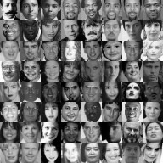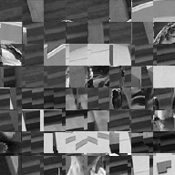

1. (b)

Figure 2: Some supervised examples: (a) positive examples (b) negative examples.

All of them are 24 × 24 grayscale images.

Computing a 24 × 24 image’s Haar-like feature vector



1: **Input:** a 24 × 24 image with zero mean and unit variance

2: **Output:** a *d* × 1 scalar vector with its feature index f ranging from 1 to *d*

3: Set the feature index *f* ← 0

4: Compute feature type (a)

5: **for** all (i,j) such that 1 ≤ *i* ≤ 24 and 1 ≤ *j* ≤ 24 **do**

6: **for** all (*w,h*) such that *i + h − 1 ≤ 24* and *j + 2w* − 1 ≤ 24 **do**

7: compute the sum S1 of the pixels in *[i,i + h − 1] × [j,j + w − 1]*

8: compute the sum S2 of the pixels in *[i,i + h − 1] × [j + w,j + 2w − 1]*

9: record this feature parametrized by *(1,i,j,w,h*): *S1 − S2*

10: *f ← f + 1*

11: **end for**

12: **end for**

13: Compute feature type (b)

14: **for** all (i,j) such that 1 ≤ *i* ≤ 24 and 1 ≤ *j* ≤ 24 **do**

15: **for** all (w,h) such that *i + h* − 1 ≤ 24 and *j + 3w* − 1 ≤ 24 **do**

16: compute the sum S1 of the pixels in *[i,i + h − 1] × [j,j + w − 1]*

17: compute the sum S2 of the pixels in *[i,i + h − 1] × [j + w,j + 2w − 1]*

18: compute the sum S3 of the pixels in *[i,i + h − 1] × [j + 2w,j + 3w − 1]*

19: record this feature parametrized by *(2,i,j,w,h): S1 − S2 + S3*

20: *f ← f* + 1

21: **end for**

22: **end for**

23: Compute feature type (c)

24: **for** all *(i,j)* such that 1 ≤ *i* ≤ 24 and 1 ≤ *j* ≤ 24 **do**

25: **for** all (w,h) such that *i + 2h* − 1 ≤ 24 and *j + w* − 1 ≤ 24 **do**

26: compute the sum S1 of the pixels in *[i,i + h − 1] × [j,j + w − 1]*

27: compute the sum S2 of the pixels in *[i + h,i + 2h − 1] × [j,j + w − 1]*

28: record this feature parametrized by *(3,i,j,w,h): S1 − S2*

29: *f ← f +* 1

30: **end for**

31: **end for**

32: Compute feature type (d)

33: **for** all *(i,j)* such that 1 ≤ *i* ≤ 24 and 1 ≤ *j* ≤ 24 **do**

34: **for** all (w,h) such that *i + 3h* − 1 ≤ 24 and *j + w* − 1 ≤ 24 **do**

35: compute the sum S1 of the pixels in *[i,i + h − 1] × [j,j + w − 1]*

36: compute the sum S2 of the pixels in *[i + h,i + 2h − 1] × [j,j + w − 1]*

37: compute the sum S3 of the pixels in *[i + 2h,i + 3h − 1] × [j,j + w − 1]*

38: record this feature parametrized by *(4,i,j,w,h): S1 − S2 + S3*

39: *f ← f +* 1

40: **end for**

41: **end for**

42: Compute feature type (e)

43: **for** all (i,j) such that 1 ≤ *i* ≤ 24 and 1 ≤ *j* ≤ 24 **do**

44: **for** all (w,h) such that *i + 2h* − 1 ≤ 24 and *j + 2w* − 1 ≤ 24 **do**

45: compute the sum S1 of the pixels in *[i,i + h − 1] × [j,j + w − 1]*

46: compute the sum S2 of the pixels in *[i + h,i + 2h − 1] × [j,j + w − 1]*

47: compute the sum S3 of the pixels in *[i,i + h − 1] × [j + w,j + 2w − 1]*

48: compute the sum S4 of the pixels in *[i + h,i + 2h − 1] × [j + w,j + 2w − 1]*

49: record this feature parametrized by *(5,i,j,w,h): S1 − S2 − S3 + S4*

50: *f ← f* + 1

51: **end for**

52: **end for**

Algorithm for Integral Image

1: **Input:** an image *I* of size *N × M*.

2: **Output:** its integral image II of the same size.

3: Set *II(1,1) = I(1,1).*

4: **for** i = 1 to *N* **do**

5: **for** j = 1 to *M* **do**

6:  *II(i,j) = I(i,j) + II(i,j − 1) + II(i − 1,j) − II(i − 1,j − 1)* and *II* is defined to be zero whenever its argument *(i,j)* ventures out of I’s domain.

7: **end for**

8: **end for**

**Algorithm for Adaboost**



1: **Input:** n training examples (xi,yi) ∈ Rd × {−1,1}, 1 ≤ i ≤ n, number of training rounds T.

2: **Parameter:** the initial probabilistic weights wi(1) for 1 ≤ i ≤ n.

3: **Output:** a strong learner/committee.

4: **for** t = 1 to T **do**

5: Run Algorithm of stumping to train a decision stump ht using the weights w·(t) and get its weighted error t

6. **if** = 0 and t = 1 **then**

7: training ends and return h1(·).

8: **else**

9: set $α_{t}$

10: update the weights

11: **end if**

12: **end for**

13: Return the rule

$f\left(t\right)=sign(\sum_{t=1}^{T}{α_{t} h_{t}(.)}$

**Cons of Voila-Jones Face Recognition algorithm**

* The face detector can detect faces that are tilted up to about ± 15 degrees in plane and about ± 45 degrees out of plane (toward a profile view).
* Problems with harsh backlighting and occlusions

### 1.3.3. Local Binary Pattern Histogram (LBPH) Algorithm

Human beings perform face recognition automatically every day and practically with no effort. Although it sounds like a very simple task for us, it has proven to be a complex task for a computer, as it has many variables that can impair the accuracy of the methods, for example: illumination variation, low resolution, occlusion, amongst other. In computer science, face recognition is basically the task of recognizing a person based on its facial image. It has become very popular in the last two decades, mainly because of the new methods developed and the high quality of the current videos/cameras.

Local binary patterns (LBP) is a type of [visual descriptor](https://en.wikipedia.org/wiki/Visual_descriptor) used for classification in [computer vision](https://en.wikipedia.org/wiki/Computer_vision). LBP is the particular case of the Texture Spectrum model proposed in 1990. Local Binary Pattern (LBP) is a simple yet very efficient texture operator which labels the pixels of an image by thresholding the neighborhood of each pixel and considers the result as a binary number. LBP was first described in 1994. It has further been determined that when LBP is combined with histograms of oriented gradients (HOG) descriptor, it improves the detection performance considerably on some datasets.

The difference between face detection and recognition is that in detection it is just needed to determine if there is some face in the image or not, but that is not in the case of recognition In face recognition, labeling of the face to respective user should be done. The basic idea of Local Binary Patterns is to summarize the local structure in an image by comparing each pixel with its neighborhood. Take a pixel as center and threshold its neighbors against. If the intensity of the center pixel is greater-equal its neighbor, then denote it with 1 and 0 if not. You’ll end up with a binary number for each pixel, just like 11001111. So, with 8 surrounding pixels you’ll end up with 2^8 possible combinations, called Local Binary Patterns or sometimes referred to as LBP codes.

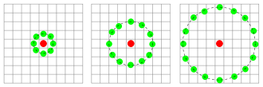

Figure 3.Illustration of LBP

#### 1.3.3.1. Steps of the algorithm

1. Parameters: the LBPH uses 4 parameters:

* Radius: the radius is used to build the circular local binary pattern and represents the radius around the central pixel. It is usually set to 1.
* Neighbors: the number of sample points to build the circular local binary pattern. Keep in mind: the more sample points you include, the higher the computational cost. It is usually set to 8.
* Grid X: the number of cells in the horizontal direction. The more cells, the finer the grid, the higher the dimensionality of the resulting vector. It is usually set to 8.
* Grid Y: the number of cells in the vertical direction. The more cells, the finer the grid, the higher the dimensionality of the resulting vector. It is usually set to 8.

2. Training the Algorithm: First, algorithm need to be trained. To do so, dataset of the images of the respective user are needed. Labelling of the image should be done either by using ID of the person or name of the person, so the algorithm will use this information to recognize an input image and give you an output. Images of the same person must have the same ID.

3. Applying the LBP operation: The first computational step of the LBPH is to create an intermediate image that describes the original image in a better way, by highlighting the facial characteristics. To do so, the algorithm uses a concept of a sliding window, based on the parameters radius and neighbors.

### 1.3.4. Cryptography

Cryptography is the process of encrypting plain text to cipher text using encryption key and decrypting cipher text to plain text using decryption key. This project consists the feature of both text messaging and image messaging. For image messaging, Image Steganography is implemented but no compromise is done in terms of security during text messaging. If someone able to find the text message in plain form then the objective of this project to implement the secure communication system will go on vain. So to take security to the new level, RSA cryptography technique is used which was developed by Rivest , Shamir and Adelson. This algorithm is an asymmetric key algorithm where there will be the use of both public and private key. Public key is used for encrypting the message and public key is used for the decrypting the message.

In computing, encryption is the method by which plaintext or any other type of data is converted from a readable form to an encoded version that can only be decoded by another entity if they have access to a decryption key. Encryption is one of the most important methods for providing data security, especially for end-to-end protection of data transmitted across networks.

Encryption is widely used on the internet to protect user information being sent between a browser and a server, including passwords, payment information and other personal information that should be considered private. Organizations and individuals also commonly use encryption to protect sensitive data stored on computers, servers and mobile devices like phones or tablets.

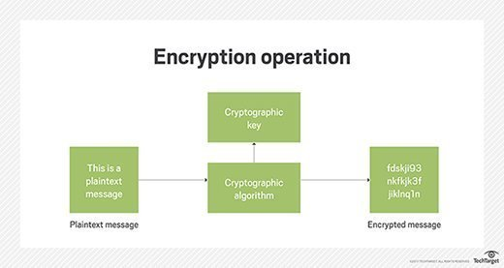

Figure 4.Block diagram of Encryption

**Types of encryption**

1. Symmetric encryption: In symmetric encryption the same key is used for encryption and decryption. It is therefore critical that a secure method is considered to transfer the key between sender and recipient.

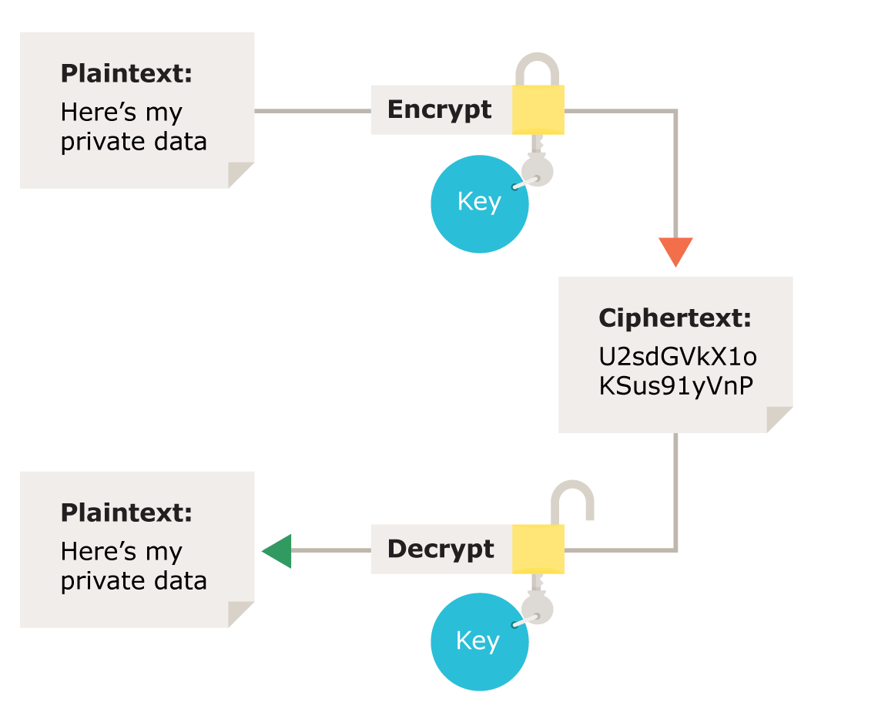

Figure 5.Illustration of Symmetric encryption

1. Asymmetric encryption: Asymmetric encryption uses the notion of a key pair: a different key is used for the encryption and decryption process. One of the keys is typically known as the private key and the other is known as the public key.

The private key is kept secret by the owner and the public key is either shared amongst authorized recipients or made available to the public at large.

Data encrypted with the recipient’s public key can only be decrypted with the corresponding private key. Data can therefore be transferred without the risk of unauthorized or unlawful access to the data.

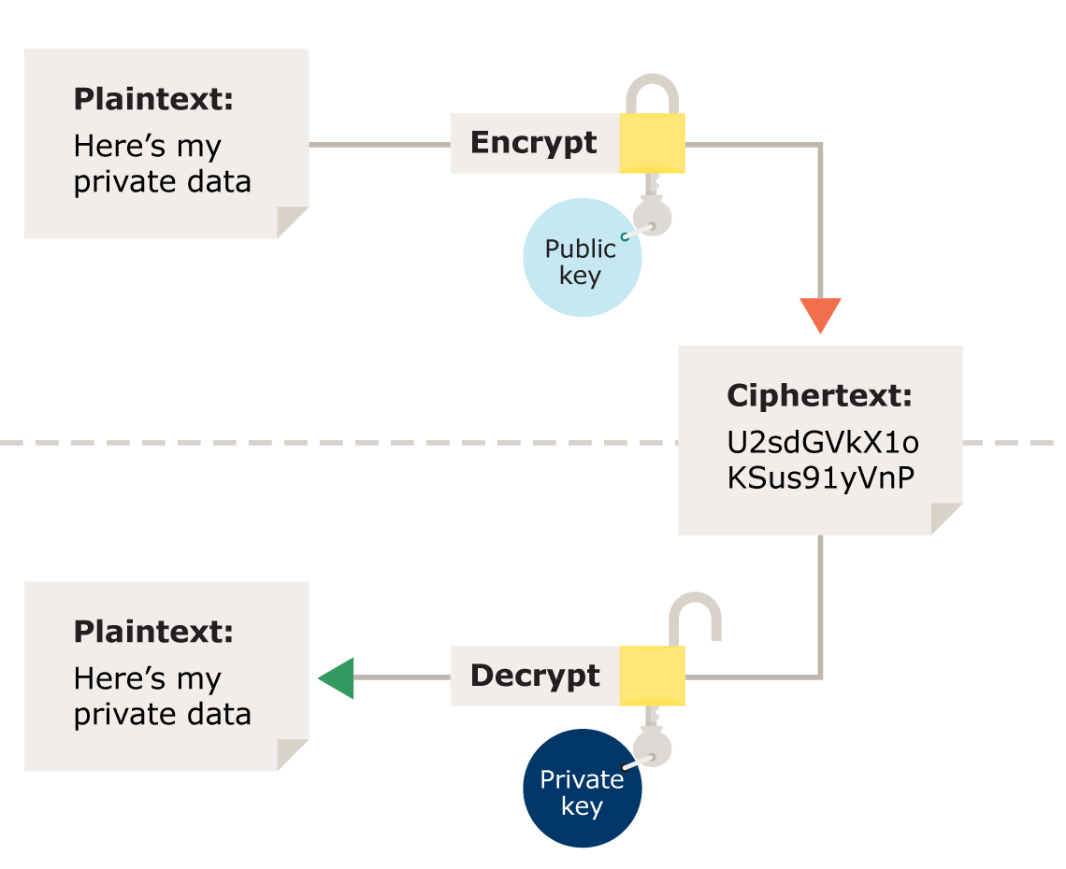

Figure 6.Illustration of Asymmetric encryption

#### 1.3.4.1. RSA(Rivest–Shamir–Adleman) Cryptography

RSA (Rivest–Shamir–Adleman) is one of the first public-key cryptosystems and is widely used for secure data transmission. In such a cryptosystem, the encryption key is public and it is different from the decryption key which is kept secret (private). In RSA, this asymmetry is based on the practical difficulty of the factorization of the product of two large prime numbers, the "factoring problem". RSA is actually a set of two algorithms:

1. Key Generation: A key generation algorithm.
2. RSA Function Evaluation: A function F, that takes as input a point x and a key k and produces either an encrypted result or plaintext, depending on the input and the key.

**Key Generation**

The key generation algorithm is the most complex part of RSA. The aim of the key generation algorithm is to generate both the public and the private RSA keys. Weak key generation makes RSA very vulnerable to attack. So, it has to be done correctly. Here is what has to happen in order to generate secure RSA keys:

For the public key, a random prime number that has a greatest common divisor (gcd) of 1 with ϕ(n) and is less than ϕ(n) is chosen. Let's choose 7 (note: both 3 and 5 do not have a gcd of 1 with ϕ(n). So e=7, and to determine d, the secret key, the inverse of 7 need to be found with ϕ(n). This can be done very easily and quickly with the Extended Euclidean Algorithm, and hence d = e-1 mod (n)=103. This can be easily verified: e⋅d=1modϕ(n) and 7⋅103=721=1mod120.

1. Large Prime Number Generation: Two large prime numbers *p* and *q* need to be generated. These numbers are very large: At least 512 digits, but 1024 digits is considered safe.
2. Modulus: From the two large numbers, a modulus n is generated by multiplying p and q, calculated as n = p*q
3. Totient: The totient of n,ϕ(n) is calculated as ϕ(n) = (p-1)*(q-1)
4. Public Key: A prime number is calculated from the range [3,ϕ(n)) that has a greatest common divisor of 1 with ϕ(n).

Public Key, PU= (e, n)

1. Private Key: Because the prime in step 4 has a gcd of 1 with ϕ(n), inverse of it can be determined with respect to modϕ(n).

Private Key, PR =(d,n)

**RSA Function Evaluation**

This is the process of transforming a plaintext message into ciphertext, or vice-versa. The RSA function, for message m and key k is evaluated as follows:

F(m, k) = 𝑚k 𝑚𝑜𝑑 𝑛

There are two cases:

1. Encrypting with the public key, and then decrypting with the private key.
2. Encrypting with the private key, and then decrypting with the public key.

**Encryption**: F(m, e)=𝑚e 𝑚𝑜𝑑 𝑛 = c, where m is the message, e is the public key and c is the cipher.

**Decryption**: F(c, d)=cd 𝑚𝑜𝑑 𝑛 = m

### 1.3.5. Network Programming

Sockets can be thought of as endpoints in a communication channel that is bi-directional, and establishes communication between a server and one or more clients. Here, socket is set up on each end and allow a client to interact with other clients via the server. The socket on the server side associates itself with some hardware port on the server side. Any client that has a socket associated with the same port can communicate with the server socket.

Every time a user connects to the server, a separate thread is created for that user and communication from server to client takes place along individual threads based on socket objects created for the sake of identity of each client.

The server side script will attempt to establish a socket and bind it to an IP address and port specified by the user. The script will then stay open and receive connection requests, and will append respective socket objects to a list to keep track of active connections. Every time a user connects, a separate thread will be created for that user. In each thread, the server awaits a message, and sends that message to other users currently on the chat. If the server encountered an error while trying to receive a message from a particular thread, it will exit that thread.

A computer’s public IP address would be required for server ip address. This would require port forwarding in cases where a node from a local network (node that isn’t the router) wishes to host the server. This requires any requests that come to the public IP addresses to be re routed towards our private IP address in our local network, and would hence require port forwarding.

The client side script will simply attempt to access the server socket created at the specified IP address and port. Once it connects, it will continuously check as to whether the input comes from the server or from the client, and accordingly redirects output.

## 1.4. Objectives

* To establish a secure means of communication.
* To avoid drawing suspicion to the existence of a hidden message.

# 2. LITERATURE REVIEW

In [1], author proposed a novel technique for image steganography based on Huffman encoding. Huffman encoding is performed over the secret image/message before embedding and each bit of Huffman code of secret image/message is embedded inside the cover image by altering the LSB of each of the pixel’s intensities of cover image. In [2], author proposed medical image based steganography. This methodology provides an efficient and storage security mechanism for the protection of digital medical images. In [3], authors has implemented LSB (Least Significant Bit) algorithm. By using bit inversion technique, the stego-image quality has been improved. For improving the robustness of steganography, RC4( Rivest Cipher 4) algorithm was implemented to achieve the randomization in hiding message image bits into cover image pixels instead of storing them sequentially. This method randomly disperses the bits of the message in the cover image and thus, harder for unauthorized people to extract the original message. The presented method shows good enhancement to Least Significant Bit technique in consideration to security as well as image quality.

A formal method of classifying faces was first proposed in [4]. The author proposed collecting facial profiles as curves, finding their norm, and then classifying other profiles by their deviations from the norm. In [5], the rapid development of face recognition is due to a combination of factors: active development of algorithms, the availability of a large databases of facial images, and a method for evaluating the performance of face recognition algorithms. In [6], face recognition was performed by independently matching templates of three facial regions (eyes, nose and mouth). The configuration of the components during classification was unconstrained since the system did not include a geometrical model of the face. Computer recognition of face images involves two crucial aspects: facial feature representation and classifier design [7]. Local Binary Patterns (LBP) [8], a non-parametric method summarizing the local structures of an image efficiently, has received increasing interest for facial representation recently [9], [10]. LBP was originally proposed for texture description [11], and has been widely exploited in many applications such as image/video retrieval, aerial image analysis, and visual inspection. To also consider the shape information of faces, Ahonen et al. [12] proposed to divide face images into m local regions to extract LBP histograms and concatenate them into a single, spatially enhanced feature histogram. The histogram encodes both local texture and global shape of the face images. Zhao et al. [13] applied Kernel LDA with LBP features for face recognition, where the kernel function was designed using Chi square distance and Radial Basis Function.

[14] In the early days of computer networks, communication between physically separated machines was only possible via expensive, dedicated lines. Engineers at Bell Laboratories came up with a milestone breakthrough in the 1960s -- the modem. This simple invention revolutionized communication networks and computer networking. [15] In 1966, Thomas Marill and Lawrence G. Roberts published a paper on an experimental Wide area network (WAN) for computer time sharing. In 1972, commercial services using X.25 were deployed, and later used as an underlying infrastructure for expanding TCP/IP networks. [16] In 1973, the French CYCLADES network was the first to make the hosts responsible for the reliable delivery of data, rather than this being a centralized service of the network itself. In 1976, John Murphy of Datapoint Corporation created ARCNET, a token-passing network first used to share storage devices. Zhang discussed about the architecture of network and client-server model in [17].

Mobile chat apps have shaped multiple forms of communication in everyday life, including education, family, business, and health communication. In journalism, chat apps have taken on a heightened significance in reporting political unrest, particularly in terms of audience/reporter distinctions, sourcing of information, and community formation in [18].With more than 3 billion users worldwide, messaging apps demonstrated one of the fastest-growing online behaviors and passed social networks. The reach of these apps is huge, which presents a strong relationship promise for marketers [19].

Nowadays, communications play an extremely important role and their wide application often leads to the significant changes in different areas and activities. In [20], collegiate recruiting is not an exception. It should be said that the progress of technologies is unstoppable and it is simply illogical to prevent coaches and recruits to use text messaging as a means of communication in the process of recruiting.[21]. Text messaging is a prominent mode of communication. While the media suggests that text messaging has adverse effects on literacy development, there is not substantive data to support these assumptions. Teleconferencing or Chatting, is a method of using technology to bring people and ideas together despite of the geographical barriers. The technology has been available for years but the acceptance it was quite recent. [22]

The project “Covert: Secret Messaging through image steganography and face recognition” is not a new concept but definitely a well presented project comprising of features that were included in different projects that were done separately as mentioned above. The major similarities with the past projects are as follows:

1. LSB method of image steganography: The project “Covert” uses least significant bit of each pixel of image to store each bit of encrypted message which had already been used in past projects.
2. LBPH face recognition: This project computes histogram of each grayscale images of the dataset, then again computes histogram of the input image, calculates the distance between two histograms and gives the output from the image with the closest histogram.
3. Socket Programming: Socket programming used in this project is not a new concept and have been used in numerous messaging applications. A socket is set on each end (i.e. server and clients) and clients are allowed to interact with each other via the server. The socket on the server side associates itself with some hardware port on the server side. Any client that has a socket associated with the same port can communicate with the server socket.

Nevertheless, the project “Covert” has striking differences and it promises for better security in messaging. The major differences are discussed below:

1. Attributes Consolidation: “Covert” consists of several attributes or features combined in a single project which were found in past projects separately. “Covert” combines cryptography, image steganography, face recognition and messaging (one to one) in a single website which had not been done previously. The combination of cryptography and image steganography ensures more secure communication.
2. More secure messaging: Unlike traditional messaging, it not only encrypts text messages but also hides each bit of encrypted message in LSB of pixels of image which can be used for communication. So, it avoids suspicion to the existence of hidden messages.

# 3.METHODOLOGY

## 3.1. Data Collection and Analysis

### 3.1.1. Primary Data Collection

For the face recognition of a particular person, the grayscale images of the face of all the individual user are stored in the dataset and that dataset is trained using the Local Binary Pattern Histogram trainer function and recognizer is run to recognize it. Images of all the user who will be logged in our system will act as a primary data. The means for collecting the primary data is webcam.

### 3.1.2. Secondary Data Collection

For the face detection, Haar-Cascade classifier for Frontal face is used which is trained with several hundred positive samples of a face and arbitrary negative images of the same size which acts as source of secondary data in our project.

Data Collection & Analysis

Primary Data

Secondary Data

Capturing faces of users through webcam

OpenCV Haar Cascade Classifier for frontal face

Figure 7. Data collection and analysis

## 3.2. Image Steganography using LSB method

Image steganography is the process of concealing the secret message inside the image such that it doesn’t create suspicion in intruders mind. To make this art happen, Least Significant Bit (LSB) method of Image Steganography is implemented. As it deals with PNG image, there consist of 3 channel layers i.e. Red, Green and Blue whose LSB can be used to encode the message inside the image. Once the user type message in the message box and press encode(E) button, Image Steganography role comes into play. To initiate this process, the preliminary part is source of Image. The duplicate of that image is created which acts as a cover image where payload can be concealed. Length of the message and the recipient of this message is figure out and then message byte is encrypted by using receiver’s public key and that ciphertext is converted into bits-form by taking reference of ASCII code for respective characters which helps to store that bits into the LSB of blue channel. Blue channel of first and second pixel is used for storing length of the message and receiver of message respectively. Length of the message and receiver id is stored because it helps to know how many pixel need to evaluated to get the original message and to validate the user who is performing face recognition is legitimate receiver of the message or not while user press the decode message .Since only the LSB of the Blue channel is changed, it will not result too much off variation in the encoded image compared to original image.

## 3.3. Face Detection (Voila-Jones algorithm)

Face Detection is done to classify whether the given sample of images consist of face or not. Voila-Jones Algorithm of face detection is use in this project for face detection consists of four steps which is discussed in the introduction part. In Haar-Feature selection for the given 24*24 image,160000+ features are extracted and using Adaboost training features get reduced dramatically but evaluating all these features at a time in the given image in real time will be time consuming. Once the classifier is trained, cascading of it is done because all the features needn’t need to be checked to detect whether given image consists of face or not. Cascading is a particular case of [ensemble learning](https://en.wikipedia.org/wiki/Ensemble_learning) based on the concatenation of several [Classifiers](https://en.wikipedia.org/wiki/Statistical_classification), using all information collected from the output from a given classifier as additional information for the next classifier in the cascade. To search for the face in the entire frame, the search window is moved across the image and check every location for the classifier. The classifier which is used in the project is trained with 10000+ positive images which consists of the face and 10000+ arbitrary negative images of the same size and features generated from that are ordered to make the cascade classifier. After the classifier is trained it can be applied to a region of an image and detect the face in the image. Unlike voting or stacking ensembles, which are multi expert systems, cascading is a multistage one. For this project, Haar-Cascade Classifier for the frontal face provided by the OpenCV is used. Face detection need to be performed before the face recognition and face detection is preliminary part for the face recognition.

## 3.4. Face Recognition (Local Binary Pattern Histogram Algorithm)

For the face recognition, Local Binary Pattern Histogram algorithm is used. To recognize the person, first image of the respective person needs to be capture and perform face detection on it. To do this, user is provided with ‘Train’ option once the user gets logged in the system. After clicking on that button, user get redirected to new window where webcam is ready to capture the images. Captured image are in RGB format .and face detection process is performed to find out whether the image consists of face or not. If faces are found in the captured image, they get converted into grayscale format and they get stored in the dataset folder labeled with respective user id. 20 samples of respective user are collected. They are converted to grayscale format because for the LPBH algorithm the images that need to be trained need to be in grayscale format. For the face to be recognized, they first need to be trained. So face recognition consists of two parts i.e. Training part and Recognition part**.**

### 3.4.1. For Training

Respective user image is extracted from the dataset folder. Every grayscale image gets converted to numpy array and userid of the respective image is extracted from the dataset path by using split operation. List of numpy array of image and list of respective user id is made and passed to the LBPH train function and LBPH Face Recognizer start to work. The sliding window of 3*3 is run over the image and intensity of the central pixel i.e in the position(2,2) get changed depending upon the value of its neighboring pixel i.e. on its left-top, left-middle, left bottom, right top ,right-middle, right bottom etc. If the intensity of the neighboring pixel is greater than intensity of central pixel, 1 is written else 0. This gives an 8-bit binary number and which get converted to decimal for convenience. This process is repeated over the whole face. After applying LBP operation intermediate image is generated which better represents the original image. Intermediate image gets divided in to 8*8 grid that means it consists of total 64 grids. For every grid, histogram is generated where X-axis is labeled with intensity which is ranging from 0 to 255 and y-axis is labeled with frequency i.e. occurrence of that intensity value in that grid. After that all the histogram of respective grid is concatenated to form a single histogram.

### 3.4.2. For Recognition

When user press the decode button, user get redirected to window where webcam is ready to capture the images. The process is same as the process done in training part but in training part the images of the user are trained with the respective id but in this case train model developed during training phase are used and check whether the image got captures belongs to the trained image or not. For this, distance between the histogram of captured image and trained image is calculated. That one histogram which has nearest distance to the histogram of captured image is given as an output from the predict function of LBPH algorithm. Output returns the id and confidence level and base on that prediction is made whether user is the legitimate receiver or not. There may be some similarities between the facial characteristics of the users and it may result some ambiguous output so to avoid this role of confidence comes into play. Confidence tells how close the histogram is and if the value of confidence is greater than 45, image is recognized as an unknown user else provide respective id and name of the user. When face match up to 5 times, message get decoded from the image and shown to the user.

## 3.5. Cryptography (RSA)

Python’s “pyca/cryptography” was used to implement RSA algorithm. A model “Prof” was made which had OneToOneField relationship with the default django user model and had fields ‘user’, ‘privatekey’ and ‘publickey’. Whenever the user object of User model is created, the object of Prof model is created. It was done by using django’s post_save signal. This means that whenever a user registers his account in the system, he would be given a primary and private key for RSA cryptography which will be stored in the database.

At first, private key for the user is generated having the key size of 2048 bits. At first, only an instance of private key is generated. To store the key in the database, the key of PEM format is required. Thus, the instance of private key is serialized to obtain the key in PEM format. OpenSSL library is used for this which is a general-purpose cryptography library that provides an open source implementation of the Secure Sockets Layer (SSL) and Transport Layer Security (TLS) protocols. The resulting key will be in byte literals but string literals is needed to store the key in database. So, ‘utf-8’ decoding is performed. Escape sequence ‘\n’ is replaced by ‘\t’ to make the key a one-line string. A public key is generated using the private key and the same above processes are applied to get a public key. Both private and public keys for a particular user are stored in database.

When a user submits/sends a plaintext message, a RESTful api is called (a JSON data containing the sender and receiver’s username and the plaintext message are sent to the api). The api extracts public key of the receiver and the plaintext message. ‘\t’ in the public key is replaced by ‘/n’ and is then encoded with ‘utf-8’ to obtain the key in byte literals. The public key is of string type; hence it is converted to its instance. Plaintext message is also encoded in ‘utf-8’ to convert string to byte literal. The plaintext is then encrypted using the public key. OAEP algorithm is used for padding. OAEP requires a cryptographic hash function. For this, MGF1 is used as Mask Generation Function. MGF is similar to cryptographic hash function except that while a hash function’s output is a fixed size, a MGF supports output of a variable length. The ciphertext is encoded to base64 format, then encoded with ‘utf-8’ encoding and then converted to string type. The resulting ciphertext is stored in the “Message” table in the database for the message persistency. i.e. ciphertext is assigned to the ‘message’ field of the MessageSerializer and then the serializer is saved. ‘message’ field of the serializer is again replaced by the original plaintext message and then returned as JSON response.

An API is called for receiving message. The api filters all the messages having respective sender and receiver id and the messages which are not read yet. The messages are serialized using “MessageSerializer” to convert them into python native datatype. Serializer data is then converted to string. Each message is marked as read and then saved. Private key of receiver is extracted for decryption and is encoded in ‘utf-8’ to convert it into byte literal. ‘\t’ is replaced by ‘\n’. The base64 messages are then decoded. Private key is converted to its instance and it is used to decrypt the ciphertext message. The plaintext obtained is in byte literal, hence it is decoded to convert it into string. ‘message’ field of serializer is updated with plaintext message and the serializer is returned as JsonResponse. The plaintext message is then displayed to the receiver.

# 4. TOOLS AND TECHONOLOGIES

## 4.1. Python

Python is a widely used high-level programming language for general-purpose programming. Python features a dynamic type system and automatic memory management, and supports multiple programming paradigms including object-oriented, imperative, functional programming, and procedural styles. It has a large and comprehensive standard library.

## 4.2. Django

Django is a free and open-source web framework, written in Python, which follows the model-view-template (MVT) architectural pattern. Django’s primary goal is to ease the creation of complex, database-driven websites. Django emphasizes reusability and ”pluggability” of components, rapid development, and the principle of don’t repeat yourself. Python is used throughout, even for settings ﬁles and data models. Django also provides an optional administrative create, read, update and delete interface that is generated dynamically through introspection and conﬁgured via admin models.

## 4.3. NumPy

NumPy is a library for the Python programming language, adding support for large, multidimensional arrays and matrices, along with a large collection of high-level mathematical functions to operate on these arrays.

## 4.4. HTML/CSS

Hypertext Markup Language (HTML) is the standard markup language for creating web pages and web applications. Web browsers receive HTML documents from a web server or from local storage and render them into multimedia web pages. HTML describes the structure of a web page semantically and originally included cues for the appearance of the document. Cascading Style Sheets (CSS) is a style sheet language used for describing the presentation of a document written in a markup language.

## 4.5. JavaScript

JavaScript (JS) is a high-level, dynamic, weakly typed, object-based, multi-paradigm, and interpreted programming language. Alongside HTML and CSS, JavaScript is one of the three core technologies of World Wide Web content production. It is used to make web pages interactive.

## 4.6. PostgreSQL

PostgreSQL is an object-relational database management system (ORDBMS. It can handle workloads ranging from small single-machine applications to large Internet-facing applications (or for data warehousing) with many concurrent users. PostgreSQL is ACID-compliant and transactional. PostgreSQL has updatable views and materialized views, triggers, foreign keys; supports functions and stored procedures, and other expandability.

## 4.7. Git

Git is a version control system (VCS) for tracking changes in computer ﬁles and coordinating work on those ﬁles among multiple people. It is primarily used for source code management in software development, but it can be used to keep track of changes in any set of ﬁles. As a distributed revision control system, it is aimed at speed, data integrity, and support for distributed, non-linear workflow.

## 4.8. AJAX (Asynchronous JavaScript and XML)

To create custom dynamic web applications a programmer must utilize Ajax. Ajax is a group of technologies that provide asynchronous two-way communication between a server and the web browser. Asynchronous communication allows the user to continue to browse the web page as sections of it are being loaded. This also allows the page to display new and updated information without refreshing the page.

## 4.9. Django Rest Framework

[Django Rest Framework](http://www.django-rest-framework.org/) (DRF) is a library which works with standard Django models to build a flexible and powerful API for our project. A DRF API is composed of 3 layers: the serializer, the view set, and the router.

**Serializers:** Django models intuitively represent data stored in our database, but an API will need to transmit information in a less complex structure. While our data will be represented as instances of our Model classes in our Python code, it needs to be translated into a format like JSON in order to be communicated over an API. Serializers allow complex data such as query sets and model instances to be converted to native Python datatypes that can then be easily rendered into JSON, XML or other content types.

# 5. Covert Messaging

Messaging system which has been developed in this project is called Covert messaging system. Covert messaging allows the exchange of real-time messages through a stand-alone application. Unlike chat rooms with many users engaging in multiple and overlapping conversations, covert sessions usually take place between two users in a private, back-and-forth style of communication.

In every messaging system, certain capabilities and functionalities are essential.

1. Real-time Communications: Real-time communications (RTC) is any mode of telecommunications in which all users can exchange information instantly or with negligible latency.
2. Chat and text messaging: Chat are commonly used in e-mail, online chatting, online discussion forum postings, instant messaging, and in text messaging (SMS), especially between cell phone users.
3. Presence Technology: Presence technology is a type of application that makes it possible to locate and identify a computing device wherever it might be, as soon as the user connects to the network. Instant messaging (IM) is a very common example. IM is the most widely used application of presence technology. With presence, users can see who is available for a conversation and what the person's preferred communication device is at any given time. The result is increased workflow and collaboration capabilities.
4. Encryption: Encryption is the conversion of data into a form, called a ciphertext, that cannot be easily understood by unauthorized people. Encryption is especially important in wireless and IM communications.

## 5.1. Features of covert messaging

1. Authentication: Authentication is the process of determining whether someone or something is, in fact, who or what it declares itself to be. Authentication technology provides access control for systems by checking to see if a user's credentials match the credentials in a database of authorized users or in a data authentication server. Users are usually identified with a user ID, and authentication is accomplished when the user provides a credential, for example a password, that matches with that user ID. Knowledge factor authentication has been used in this project.
2. Text Messaging: The exchange of text message on real-time has long been the chief function of messaging, but it is now one feature of many. Conversation can be made on real-time and can instantly reply to the message. This is the one-to-one or user-to-user messaging. To get this service, ajax and serializer technology are used.
3. Image Messaging: The ability to encode secret text message to images - a capability known as Image Steganography and decode this message at receiver side with face recognition authority is another chief function of instant messaging, as are image file transfers. When the secret text messages are encoded into images file using image steganography then it sent to the recipient side. The receiver can decode this secret text message encoded within image file through mean of the face detection and recognition. When receiver click the decode button then the webcam of the device (laptop, desktop etc.) is enable and start to detect the face and recognize the respective receiver face. If the face is detected more than 5 times then the secret message will be decoded successfully. There might be other feature such as group chat, voice calls or video conferencing, which are not implemented in this instant messaging.
4. Presence technology: One of the core features of messenger clients is the ability to see whether a friend or co-worker is online and connected through the selected service -- a capability known as presence. Presence enables users to see the availability of their contacts -- whether they are online or offline.
5. Conversation List: One of the many features is to list out the newly/recently arrived/received or sent message on the left message section of the covert messaging ordered by the timestamp of the message created. This feature is essential in client side to display the recent private conversation. In this section, the recently created messages are also display with limited length of the string.
6. Search: In computer science, a search algorithm is any algorithm which solves the search problem, namely, to retrieve information stored within some data structure, or calculated in the search space of a problem domain. Examples of such structures include but are not limited to a linked list, an array data structure, or a search tree. The appropriate search algorithm often depends on the data structure being searched, and may also include prior knowledge about the data. Searching also encompasses algorithms that query the data structure, such as the SQL SELECT command.
7. Retrieve Information: Since the search is the essential in order to retrieve information stored within some data structure. In this real-time covert messaging system, search is used to retrieve information about the user with whom user had made conversation as well as to retrieve the user from friend list section. There has also another search section in order to discover the other user.
8. Encryption & Decryption Message: Encryption is the method by which plaintext or any other type of data is converted from a readable form to an encoded version (ciphertext) that can only be decoded by another entity if they have access to a decryption key. Asymmetric Encryption has been implemented to provide data security, specially for end-to-end protection of data transmitted across network. Rivest, Shamir and Adleman (RSA) encryption is the widely used asymmetric encryption algorithm. RSA algorithm has been implemented in this instant messaging to protect the transmitted message.
9. Data Persistent: Persistence is "the continuance of an effect after its cause is removed". Message data are stored in database (PostgreSQL), so that it can be retrieved when it is required, which make covert persistent. This means the data survives after process with which it was created. In other words, for a data store to be considered persistent, it must write to non-volatile storage.
10. Friendship Relationship: This enables to create and manage bi-directional friendships between users. It offers social features to help you connect users and store their social relationship. A user can add another user, and if that user accepts the request, they become friends. One can view the requests received, requests sent, friends and other users. It features:
11. Friendship request objects that can be accepted or rejected.
12. Hooks to easily list all friend requests sent or received by a given user.
13. Integration with AUTH_USER_MODEL.
14. Validation to prevent common mistakes like friend request already sent.
15. Faster server response time through caching.

# 6. SOFTWARE DEVELOPMENT LIFE CYCLE

The project used Agile Software Development methodology for the development of the software because of its benefits over traditional waterfall which did not handle bugs and feature changes well or dealt with them so late in the process that projects were seriously delayed. With Agile Software Development, the project was successfully completed within a given deadline and necessary changes were easily made when needed without any delay.

## 6.1. Agile Software Development

Agile is a methodology that promotes iterative development throughout the life-cycle of the project, close collaboration between the development team and business side, constant communication, and tightly-knit teams. It focuses on the clean delivery of individual pieces or parts of the software and not on the entire application. It is a set of methods and practices based on the values and principles expressed in the Agile Manifesto.

### 6.1.1. Agile Software Development Values

1. **Individuals and Interactions**

Tools and processes are important, but it is more important to have competent people working together effectively. Self-organization and motivation are important, as are interactions like co-location and pair programming. It is better to have a good team of developers who communicate and collaborate well, rather than a team of experts each operating in isolation. Communication is a fundamental concept.

1. **Working Software**

Good documentation is useful in helping people to understand how the software is built and how to use it, but the main point of development is to create software, not documentation.

1. **Customer Collaboration**

A contract is important but is no substitute for working closely with customers to discover what they need. Requirements cannot be fully collected at the beginning of the software development cycle, so it is better to directly involve the paying customer and their end-users, or a proxy for them so that detailed requirements can be progressively elaborated and adapted based on feedback.

1. **Responding to change**

A project plan is important, but it must not be too rigid to accommodate changes in technology or the environment, stakeholders' priorities, and people's understanding of the problem and its solution.

### 6.1.2 Agile Software Development Principles

1. Customer satisfaction by early and continuous delivery of valuable software.
2. Welcome changing requirements, even in late development.
3. Working software is delivered frequently (weeks rather than months).
4. Close, daily cooperation between business people and developers.
5. Projects are built around motivated individuals, who should be trusted.
6. Face-to-face conversation is the best form of communication (co-location).
7. Working software is the primary measure of progress.
8. Sustainable development, able to maintain a constant pace.
9. Continuous attention to technical excellence and good design.
10. Simplicity—the art of maximizing the amount of work not done—is essential.
11. Best architectures, requirements, and designs emerge from self-organizing teams.
12. Regularly, the team reflects on how to become more effective, and adjusts accordingly

### 6.1.3. Characteristics of Agile Software Development Process

1. **Scrum**

It is the most popular way of introducing Agility due to its simplicity and flexibility. Scrum emphasizes empirical feedback; team self-management, and striving to build properly tested product increments within short iterations.

1. **Quality**

Testing is integrated throughout the lifecycle, enabling regular inspection of the working product as it develops. This allows the product owner to make necessary adjustments gives the product team early sight of any quality issues.

1. **Visibility**

Agile development principles encourage ‘user/client’ active involvement throughout the product’s development process. This provides excellent visibility for key stakeholders, both the project’s progress and the product itself, which in turn helps to ensure that expectations are effectively managed.

1. **Early Identification and Resolution of issues**

Small incremental releases made visible to the product owner and product team through its development help to identify any issues early and make it easier to respond to change. The clear visibility in agile development helps to ensure that any necessary decisions can be taken at the earliest possible opportunity, while there’s still time to make a material difference to the outcome.

1. **Accommodating change due to volatile requirements (Flexibility / Agility)**

In agile development, change is accepted. Instead the timescale is fixed and requirements emerge and evolve as the product is developed. Of course for this to work, it’s imperative to have an actively involved stakeholder who understands this concept and makes the necessary trade-off decisions, trading existing scope for new.

1. **Iterative releases, Communication, continuous integration**

The active involvement of a user representative/product owner, the high visibility of the product and progress, and the flexibility to change when change is needed, creates better business engagement and customer satisfaction. This is an important benefit that can create much more positive and enduring working relationships.

1. **More Enjoyable!**

The active involvement, cooperation and collaboration make agile development teams a much more enjoyable place for most people. Instead of big specs, requirements in workshops is discussed. Instead of lengthy status reports, team collaborates around a task-board discussing progress. Instead of long project plans and change management committees, there are discussions on what’s right for the product and project and the team is empowered to make decisions. In my experience this makes it a much more rewarding approach for everyone. In turn this helps to create highly motivated, high-performance teams that are highly cooperative.

1. **Transparency**

An Agile approach provides a unique opportunity for clients to be involved throughout the project, from prioritizing features to iteration planning and review sessions to frequent software builds containing new features. However, this also requires clients to understand that they are seeing a work in progress in exchange for this added benefit of transparency.

1. **Early and Predictable Delivery**

By using time-boxed, fixed schedule Sprints of 1-4 weeks, new features are delivered quickly and frequently, with a high level of predictability. This also provides the opportunity to release or beta test the software earlier than planned if there is sufficient business value.

1. **Predictable Costs and Schedule**

Because each Sprint is a fixed duration, the cost is predictable and limited to the amount of work that can be performed by the team in the fixed-schedule time box. Combined with the estimates provided to the client prior to each Sprint, the client can more readily understand the approximate cost of each feature, which improves decision making about the priority of features and the need for additional iterations.

### 6.1.4. Advantages of Agile Method

1. Software projects change constantly. When customers are expected to finalize requirements before they can test-drive the prototypes, overhead and long delays often cripple the project. Agile Project Management is about embracing change, even late in the development stage. It’s about delivering the features with the greatest business value first, and having the real-time information to tightly manage cost, time and scope.
2. Agile Project Management reduces complexity by breaking down the many-months-long cycle of building requirements for the whole project, building the entire product and then testing to find hundreds of product flaws. Instead small, usable segments of the software product are specified, developed and tested in manageable, two- to four-week cycles.
3. In traditional waterfall project management, the Project Manager is burdened with balancing project scope, cost, quality, personnel, reporting, risk, and adapting as requirements change. Agile project management divides these overwhelming responsibilities among three agile roles.
4. Agile project management continuously evaluates time and cost as primary constraints. Rapid feedback, continuous adaptation and QA best practices are built in to the team’s committed schedules, ensuring top-quality output and proven processes.
5. Agile processes release the software development teams from following a strict set of steps and allow developers to concentrate their creative energies on the system under development. Agile processes are designed to rapidly handle changes to both the application being developed and the process itself.
6. Agile Project Managers look at proactive, real-time delivery metrics such as Velocity, Burndown and Cumulative Flow versus frequently out-of-date Gantt Charts, spreadsheets and irrelevant or impossible project milestones. As a net result, there is fewer costly end-of-project surprises, and the working product is delivered in weeks rather than months.

# 7. DIAGRAMS

## 7.1. Block Diagrams

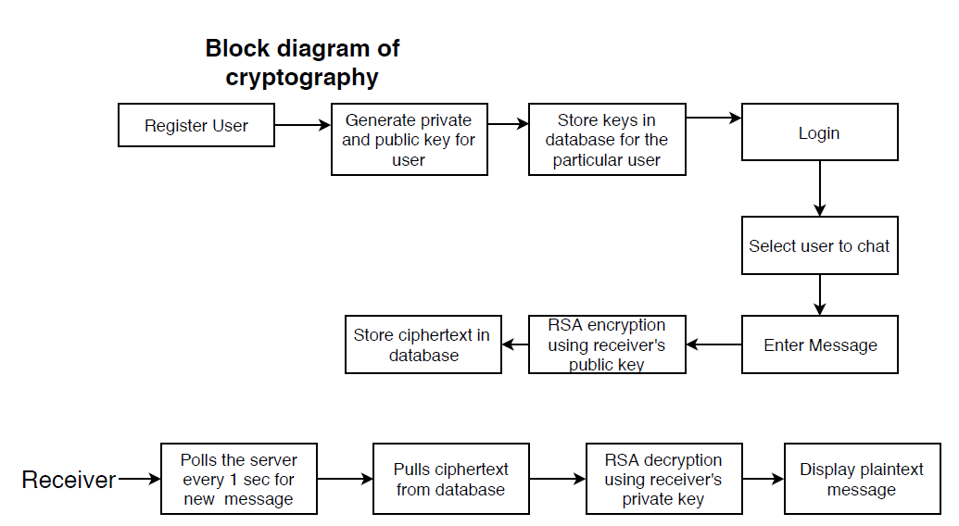

Figure 8.Block diagram of cryptography

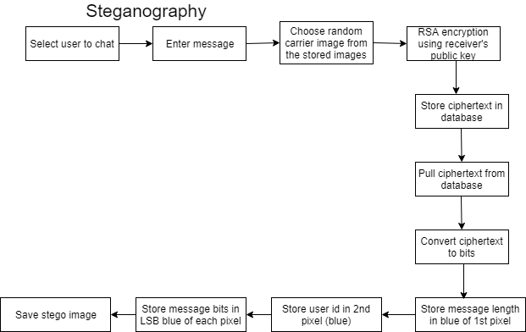

Figure 9.Block diagram of steganography

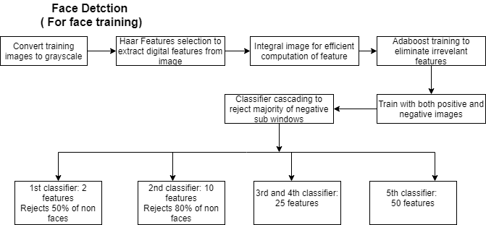

Figure 10.Block Diagram of Face detection and training

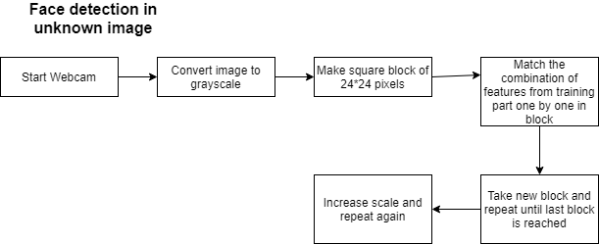

Figure 11.Block Diagram of Face detection in unknown faces

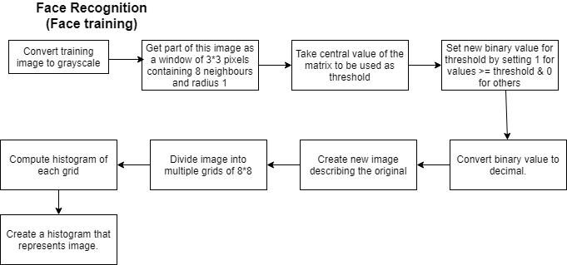

Figure 12.Block Diagram of Face Recognition and training

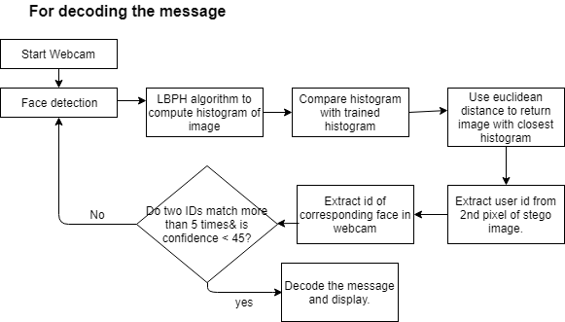

Figure 13.Block Diagram for detecting the message

## 7.2 UML Diagrams

### 7.2.1 Use-case Diagram

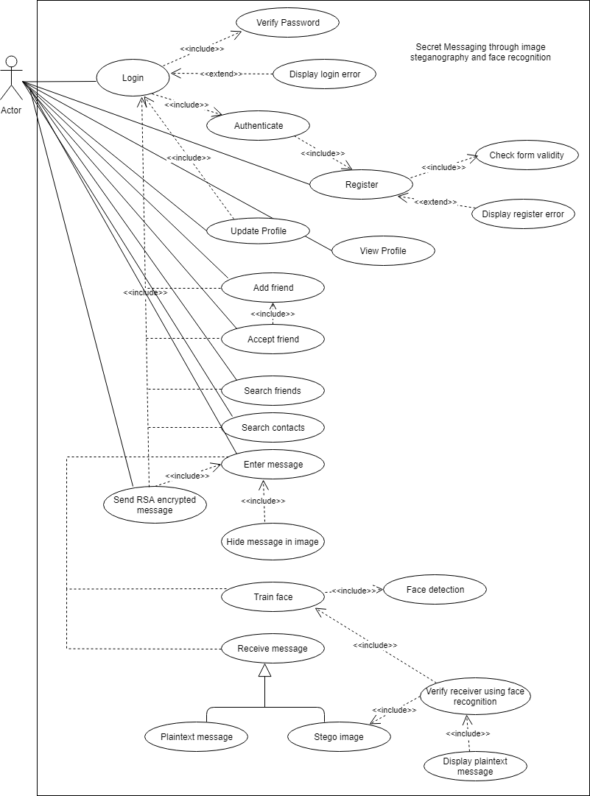

Figure 14.Use-case Diagram of system

### 7.2.2 Class Diagram

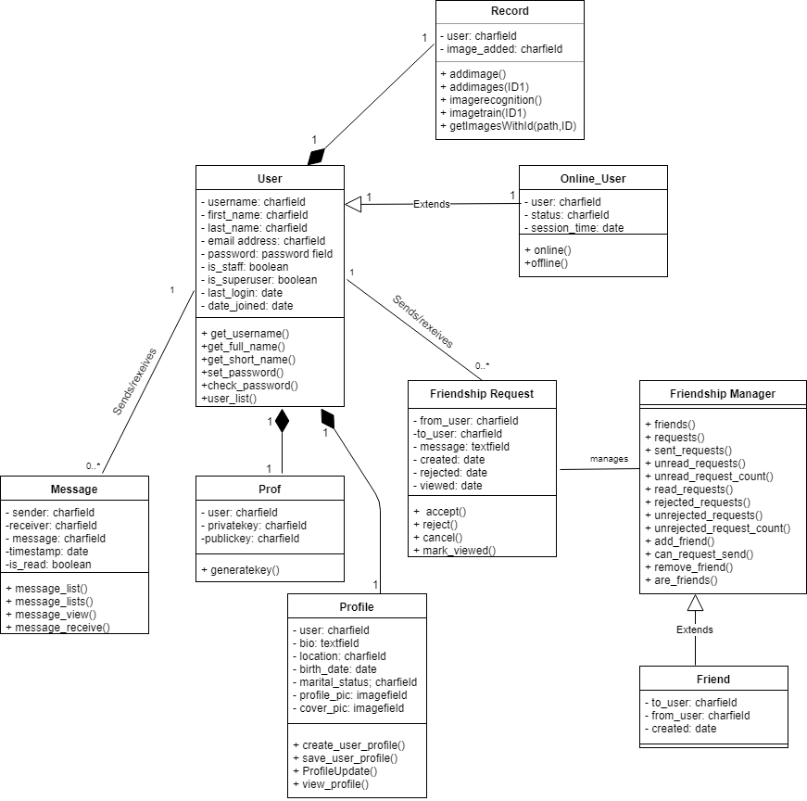

Figure 15.Class Diagram of system

### 7.2.3 Activity Diagram

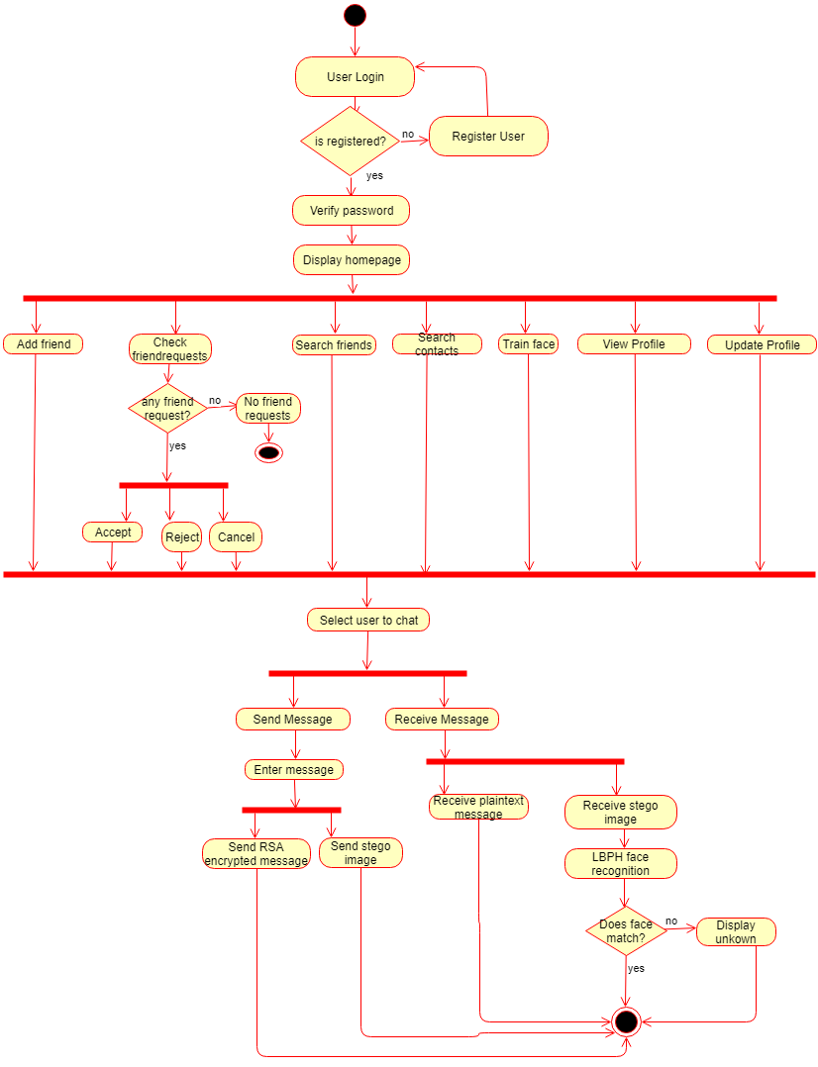

Figure18.Activity Diagram of system

### 7.2.4 Sequence Diagram

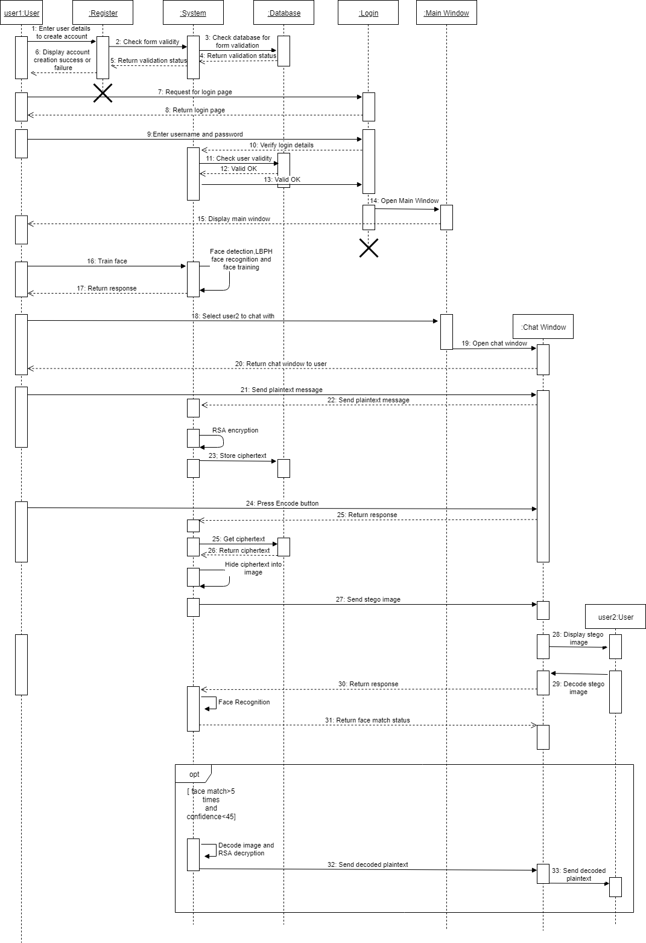

Figure 16.Sequence Diagram of system

# 8. RESULTS AND ANALYSIS

All the algorithm used in this project are working as expected. The message before encoding into the image and message after decoding from the image is same which shows that LSB method of Image Steganography is working properly. This same holds with the RSA cryptography. There is some minor flaw in the face recognition algorithm and to avoid that flaw confidence value of the face captured and face matched in the train model is used as a reference to determine whether the user is legitimate receiver or not. Results of the project along with their analysis are shown below:

**Image Before Steganography & After Steganography**



Figure 16: Image Before Steganography



Figure 17.Image After Steganography

Message = “Steganographyis the practice of concealing a file, message, image, or video within another file, message, image, or video. The word steganography combines the Greek words steganosmeaning covered, concealed, or protected, and grapheinmeaning writing.”

The message which has a length of 251, has been encoded into the image as shown in figure 17 and the output after steganography is shown in figure18. Looking at both the images, one can’t distinguish that the message has been encoded in figure 18. Hence, this help us to encode secret message within images without acknowledge of 3rd party.

**LSB in PNG image format vs LSB in JPG image format**

It was observed that conventional LSB is not effective in case of JPEG as the data gets manipulated on compression due to its lossy nature. Whereas for a PNG image a simple LSB is applicable without any loss of data on compression. Also, they both fair almost equal in terms of storing capacity and image quality of final image.

**Change in the retention of the neighbor pixel keeping scale factor constant**

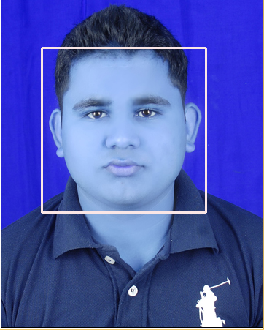

Figure 18: Change in the retention of neighbor pixel(1)

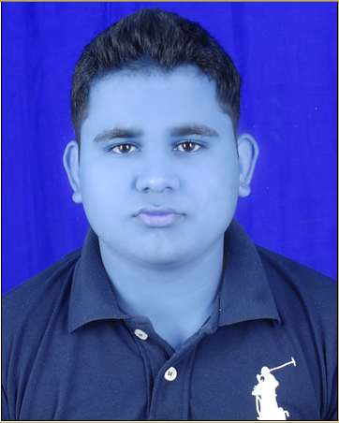

Figure 19: Change in the retention of neighbor pixel(2)

Figure 18 shows the image when scale factor =1.3 and retention of the neighbor pixel=5 and it can be cleary seen that face has been detected perfectly but this is not the case when scale factor is constant and retention of the neighbor pixel is equal to 50 which is shown in the Figure 19.

# 9. CONCLUSION

Security is an important issue while transferring the data using internet because any unauthorized individual can compromise the data and make it useless or obtain information un- intended to him. In this project, Covert system had been developed that hides maximum secret information which is immune to external attacks and also conceal the fact that the image is carrying secret information. RSA cryptography technique is used where the size of public and private key is of 2048-bits which make it impossible for any hacker/intruders to crack it. Along with cryptography and steganography, LBPH algorithm for face recognition is used which helps to take security of the system to the new level. Hence, objectives to establish a secure means of communication and to avoid drawing suspicion to the existence of a hidden message is met.

There is always a room for improvements in any projects. In future this project may be extended to include features such as Image steganography could be extended to audio-video steganography, new feature which enable the user to recover accounts and lost passwords using facial identification could be designed as an alternative to the email verification used to reset passwords or recover accounts, LBPH algorithm could be replaced by OpenFace algorithm which works efficiently with lesser training datasets giving higher accuracy. . AJAX is used for real time messaging, WebSocket could be implemented for this purpose.

This project can be extended to a level such that it can be used for the different types of image formats like .bmp, .jpeg, .gif etc.in the future.

# 10. REFERENCES

[1] Das,R and Tuithung T. (2012). Image steganography based on Huffman encoding and LSB algorithm.

[2] Prabakaran, G.; Bhavani, R. and Rajeswari P.S. (2013). Medical image based steganography.

[3] Akhtar, N.; Johri, P.; Khan, S.( 2013). Implemented LSB (Least Significant Bit) algorithm.

[4] Francis Galton.(1888). Personal identification and description.

[5] W. Zaho.(1999). Robust image based 3D face recognition

[6]. R. Brunelli and T. Poggio.(1993). Face recognition: Features versus templates.

[7] A. Hadid, M. Pietikäinen, and T. Ahonen. (2004). A discriminative feature space for detecting and recognizing faces

[8] T. Ojala, M. Pietikäinen, and T. Maenpaa. (2002). Multiresolution gray-scale and rotation invariant texture classification with local binary patterns

[9] T. Ahonen, A. Hadid, and M. Pietikäinen.(2006). Face description with local binary patterns: application to face recognition.

[10] C. Shan, S. Gong, and P. W. McOwan. (2009). Facial expression recognition based on localbinary patterns: a comprehensive study.

[11] T. Ojala, M. Pietikäinen, and D. Harwood.(1996). A comparative study of texture measures with classification based on featured distribution.

[12] T. Ahonen, A. Hadid, and M. Pietikäinen. (2004).Face recognition with local binary patterns.

[13] J. Zhao, H. Wang, H. Ren, and S.C. Kee. (2005). LBP discriminant analysis for face verification.

[14] Stanard, J. (1998, May 31). A History of (Communications) Networks**.**

[15] Roberts, Larry; Marrill, Tom .(1966). Toward a Cooperative Network of Time-Shared Computers.

[16]Bennett, Richard.(2009). Designed for Change: End-to-End Arguments, Internet Innovation, and the Net Neutrality Debate.

[17] Zhang, H. (2013). Architecture of Network and Client-Server model.

[18] Belair-Gagnon, V.(March 27, 2017).The Changing Physical and Social Environment of News gathering. Retrieved from <http://journals.sagepub.com/doi/full/10.1177/2056305117701163>

[19] Husson T. (September 19, 2016).The Future Of Messaging Apps. Retrieved from <https://go.forrester.com/blogs/16-09-19-the_future_of_messaging_apps/>

[20] Goggin, G.(2006). The Advantages of Text Messaging in Collegiate Recruiting. Retrieved from <http://samples.professay.com/text-messaging-in-collegiate-recruiting-research-paper/>

[21] Wood,C,(2014). Text Messaging and Literacy: The Evidence

[22] Rawshan, L.(2017). CHAT APPLICATION

# APPENDIX A: SCREENSHOTS

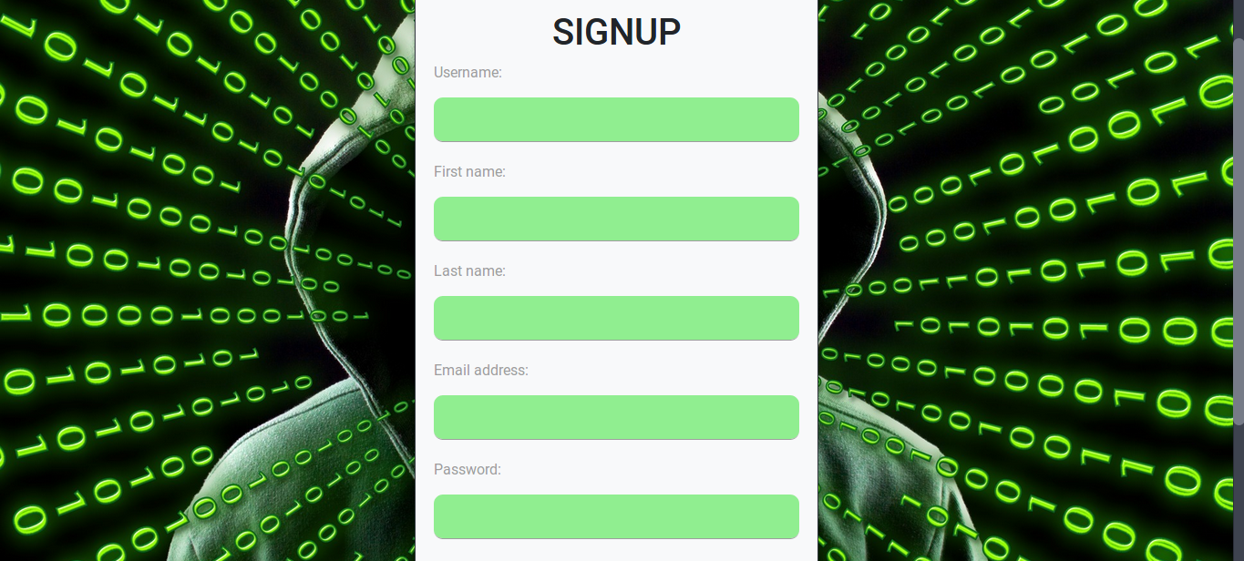

Figure 20: Registration Page

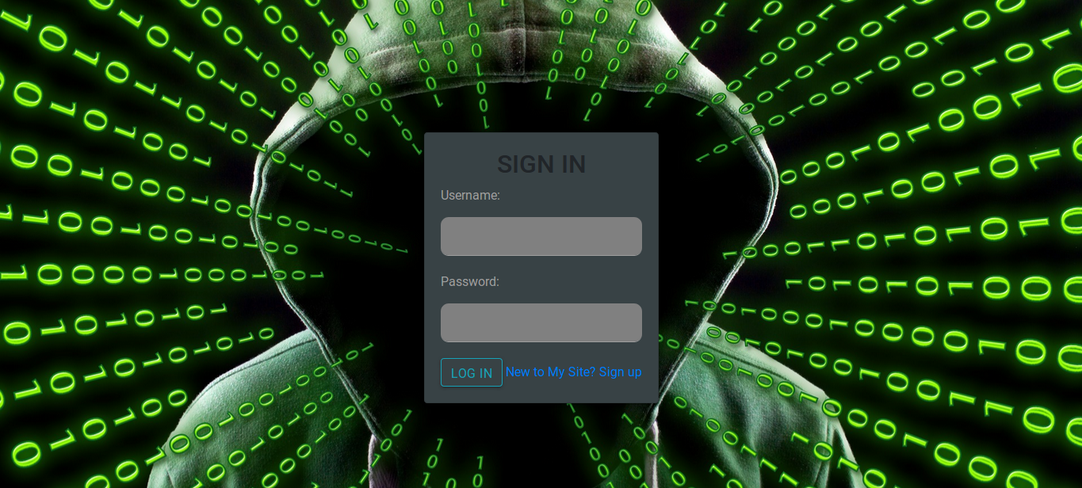

Figure 21:Login Page

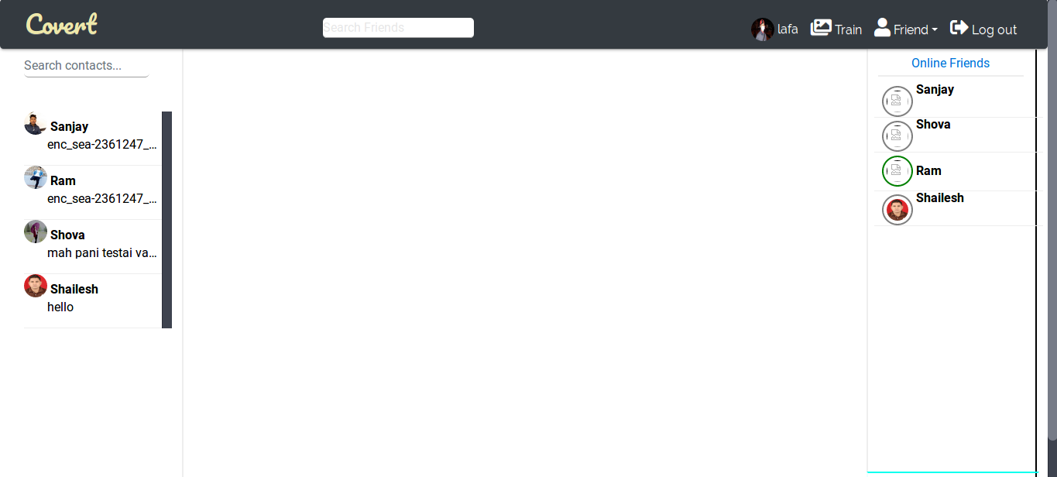

Figure 22: Homepage

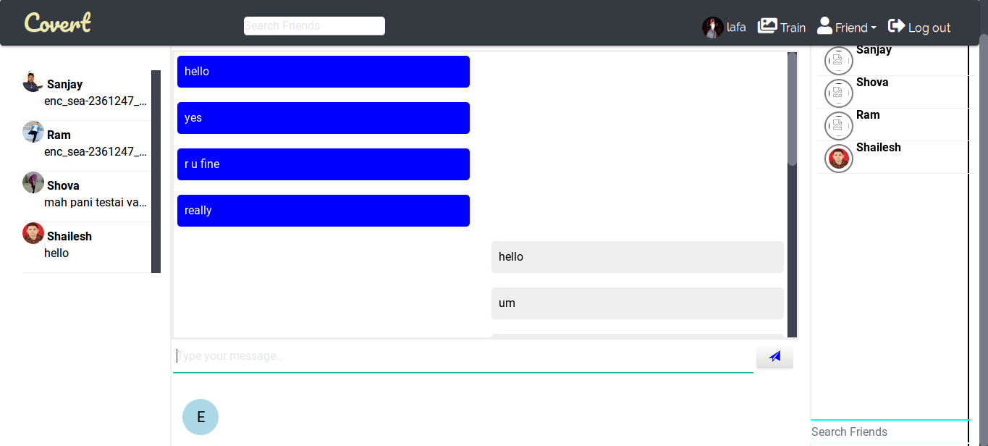

Figure 23: Messaging box

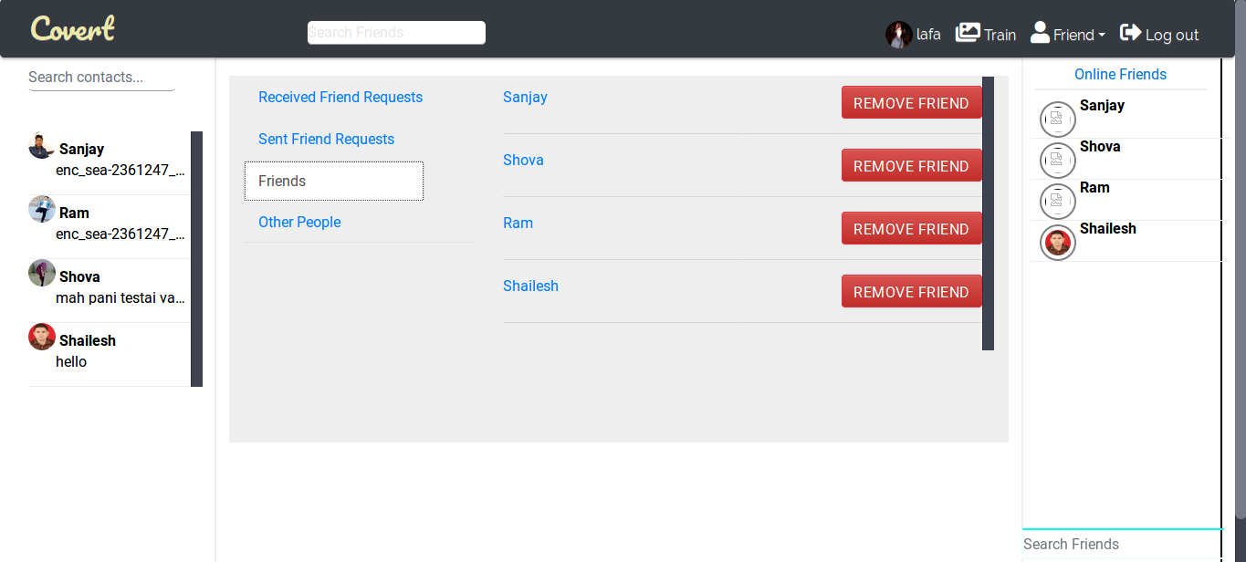

Figure 24 : Friendlists

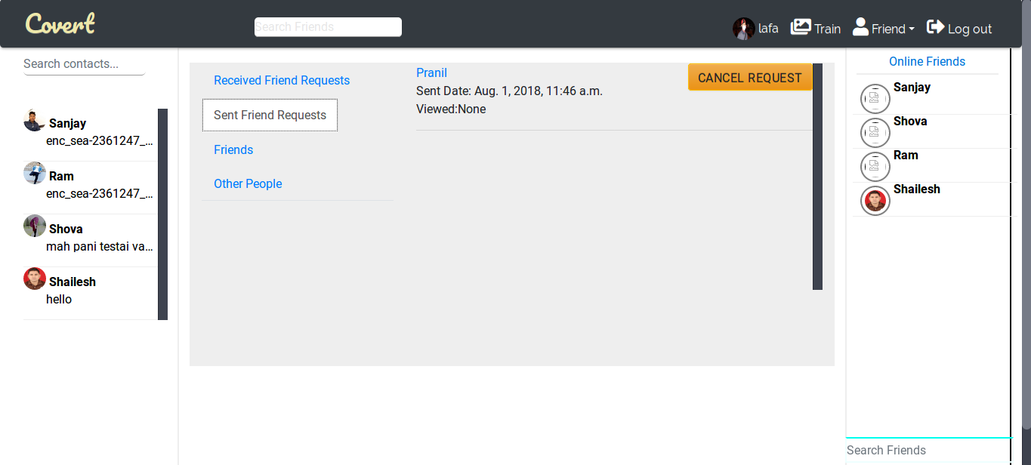

Figure 25: Received Friend Requests

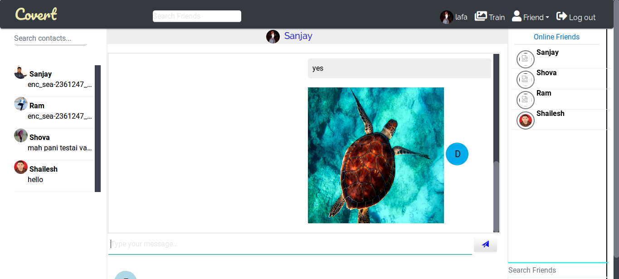

Figure 26 : Message box after sending Image

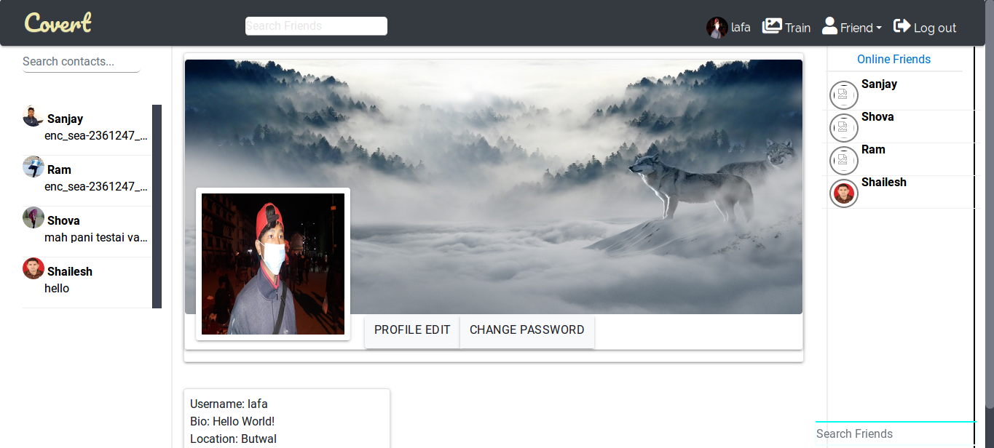

Figure 27: Viewing Profile